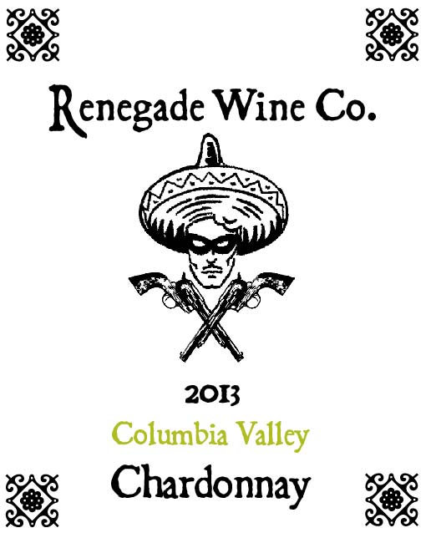

The Renegade Wine Co. is proud to present our newest creation, the 2013 Columbia Valley Chardonnay. 1500 cases of this gem were produced and they WILL go quickly. Aged in all stainless steel, it is a crisper style of Chardonnay, with aromas and flavors of tree fruits like pears and green apples. It is a versatile Chardonnay that will pair well with salads and appetizers, as well as some fish dishes. It will also be a great summertime sipper, unless of course we are sold out by summer! Grab it while you can, be a Renegade!

The Renegade Wine Co. wines are brought to you by the talented winemaking team at Sleight of Hand Cellars!

